Response to Reviews of “INSERT MANUSCRIPT TITLE HERE.”

Editor
Dear XXXXXX
We thank you for considering our manuscript and the two reviewers for their positive and constructive feedback. We have made several revisions to the manuscript to incorporate their suggestions and provide our point-by-point responses below.
We have put significant further thought into Reviewer 1’s three remaining concerns. While we acknowledge the wider importance of each of the topics raised, we do not believe the substantial additional analyses suggested by Reviewer 1 are possible within the scope of this study. We have articulated below the reasons for our position on each point in greater detail. We have also made further additions to the manuscript text to address the issues raised, including further acknowledgement of the role of XXX and the limitations of YYYY. We hope that Reviewer 1 can allow that, while the three additions requested are all valid and important research ideas within this broader topic, they do not belong in the current paper.
We again thank Reviewer 2 for their positive endorsement of our study and their insightful suggestions to improve the manuscript. We have fully incorporated the five additional suggestions made by Reviewer 2. We believe that the changes to the presentation of figures have improved the manuscript further by clarifying our key findings and helping to distinguish the robust results from those that may be due to small sample size effects. We are also grateful for the suggestions to add a fuller concluding paragraph and to further explore the role of ZZZZ in supporting XXXX.
In our responses below, the reviewers’ comments are in plain black text and our responses in blue text, with quoted additions to the manuscript in italic text. All line numbers refer to the revised text without tracked changes.
Thank you again for your consideration of our manuscript. We look forward to hearing from you.
Your sincerely,
XXXXXX

Reviewer 1
This paper presents a well written study into the effects of factors such as wind, illumination, etc. on models produced for vegetation through structure from motion photogrammetry. I have made a few minor requests for clarification in the attached document.
Response: thank you for your positive and encouraging assessment of our manuscript. We have implemented the minor clarifications as described below.

L129: insert comma after “SfM”.
Response: Suggestion accepted.

L132-133: what do these numbers mean?
Response: We have clarified the text to be more clear that these numbers refer to the location of the study site. The revised text now reads: “The study site was situated at Boldventure, near Eworthy mid Devon (Figure 1A, Latitude 50.741, Longitude 4.213).”

L211-214: Would be interesting to read why you use this method rather than other ones (e.g., what's available in Metashape).
Response: We used this method for DTM extraction rather than the algorithm available within MetaShape because this implementation is fully open source and therefore fully understandable and reproducible. Additionally, we would have needed coordinates to be imported into Metashape, and preferred to implement as much of our workflow as possible within the R environment so that it could be more easily automated and the codebase shared.

L444-446: Perhaps include species examples here from the extreme cases.
Response: We feel that providing examples of specific species would be too reductionist, as this does not fully explain the level of ecophenotypic variation that can occur between individual plants in growth form and limb properties. We think it is more constructive to retain the focus on the properties that matter, as the onus is on researchers and survey practitioners to think about these in relation to their study subjects.

L472-473: Again, I think it would be useful to name the species you have in mind here.
Response: We have a similar view to the response above in that we feel that providing examples of specific species would be too reductionist, as there is considerable height variation within species. We think it is more constructive to retain the focus on the properties, as the onus is on researchers and survey practitioners to think about these in relation to their study subjects.

Reviewer 2
General Comments: The authors evaluate multiple factors that may adversely impact the accuracy of canopy height derived from structure from motion using 61 repeat drone flights flown over a period of 24 days in 2021. They evaluate wind speed, solar elevation and illumination conditions (clear sky, partial cloud cover and overcast conditions) for retrievals from four dominant cover types, Festuca, Ulix, Salix and Betula. Overwhelm, I thought this paper was in very good condition. The study objectives are clear, methods sound, manuscript is well structured and is well illustrated. Their use of supplementary material was strategic. The subject, while not my area of specialization, appears to be important, especially in evaluating the effects of environmental conditions in the use of repeat acquisition of drone imagery to derive vegetation structural information.
Response: Thank you for your positive and constructive assessment of our manuscript. We are pleased that you recognised the value of this work to inform the practice of a large community of researchers worldwide. We have implemented the minor suggestions as described below.
Specific Comments:
Line 79. Perhaps “upper” instead of “outer”?
Response: Thank you for this suggestion, on reflection we think that ‘extremities’ is a more precise term for what we mean here, as the outer/upper terminology differs between different plant growth forms that we have worked with over a number of projects.
Line 101. Add “of” to “all of the“
Response: Suggestion accepted.
Line 178. “… and humidity were”
Response: Changes implemented

Reviewer 3
Data visualization: Please for all plots in Fig. 2, Fig. 3 or Fig. 4 only show 95% of the data (cut or flag below the 2.5% and above the 97.5% percentile), because it is obvious that some patterns are not physically possible and are only produced by small sample size effects. For example, GPP decreasing with higher MAP above 500 mm in the shrublands of Fig. 2.
Thank you for this suggestion to improve the interpretability of our figures. As you suggest, we have amended Figures 2-4 and Supplementary Figures S16-21 to exclude the most extreme values of the output variables. We find that even removing just the top and bottom 0.5% of the data distribution is sufficient to exclude the few extreme data values that lead to the anomalous visualisation results such as the response of shrublands to higher MAP, while also clarifying the differences between land covers. Combined with the confidence intervals already included, we feel the figures now clearly communicate the robust results of our analysis.
The updated figures are presented below for reference.
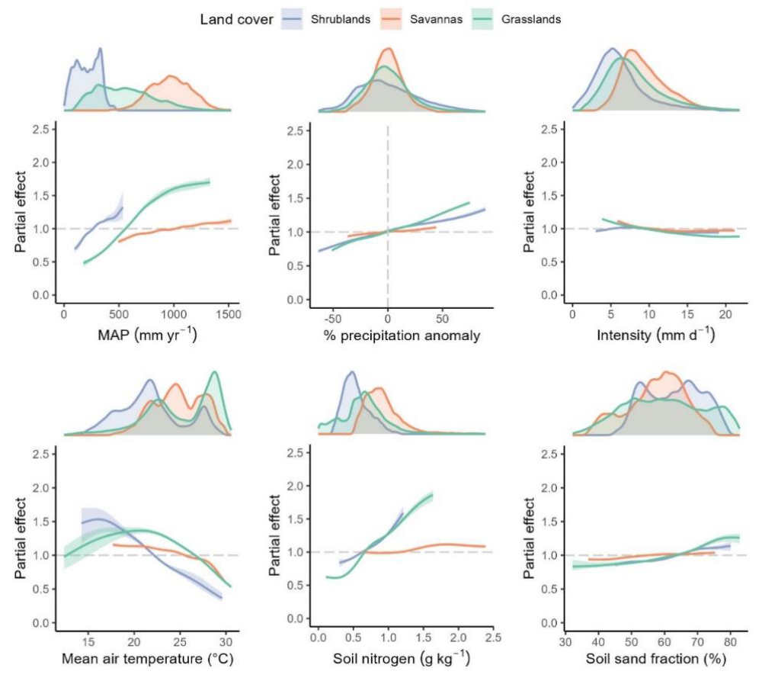
Figure 2: GAM partial effect plots for the combined model. The y-axis scale represents the proportional increase or decrease in predicted GPP associated with a change in each covariate relative to its mean value. Curves represent the mean of three models with different degrees of complexity in the spatial term. Shaded areas represent the outer envelope of 95% confidence intervals from the four models. Density plots above each sub-plot show the distribution of data points (pixels) for each covariate and land cover class. Curves are limited to the central 99% of the data range for each panel and cover type to reduce the impact of outlier values. Only curves with significant nonzero effect sizes are shown; see Supplementary Figure 16 for full results. Abbreviations: MAP – Mean Annual Precipitation.
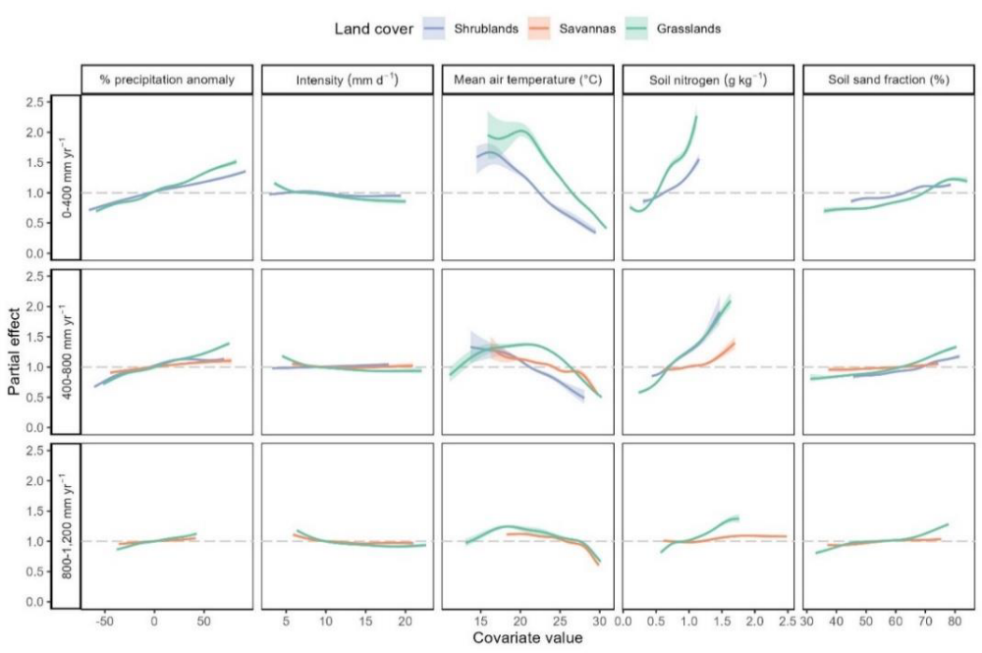
Figure 3: GAMs were re-fitted separately to three subsets of the data with different ranges of mean annual precipitation. The y-axis scale represents the proportional increase or decrease in predicted GPP associated with a change in each covariate relative to its mean value. Curves are limited to the central 99% of the data range for each panel and cover type to reduce the impact of outlier values.

REFERENCES

